### Tesla Coil Future Work

**Box**

The CAD drawings for the box that will hold Tesla coil can be found in Appendix X. This box has been made for health and safety reasons to prevent any contact with the spark at the end of the secondary coil which can cause first degree burns. It is made from transparent Perspex so its functionality can be seen by the audience. There is an adjustable microphone stand that can slide in and out to change the distance between the microphone and the spark which produces the sounds. It will be adjusted so that the microphone is as close as possible to the spark but not too close as the noise will be distorted due to the electric field created by the coil.

**FW**

The Tesla coil circuit has been split into two main parts, the switching circuit and the coil section. In the future the coil section can be enlarged to make room for a larger primary and secondary coil which will have more turns and therefore a larger spark, producing louder sounds. This would also call for a larger container such as a Faraday Cage to prevent the sparks from escaping and causing damage.

**Packaging**

In order to achieve the aim of flexible and transportable instruments, the instruments were packed into transportable boxes. Figure 1 (a) shows the largest parts of the keyboard instrument packed into a flight case. The case has space for further parts or power supplies but if there are not other parts it will be filled with bubble wrap so that everything will stay in place avoiding dislodging and damage during transportation and movement.

Figure 1 (b) shows a box that is packed with the xylophone, stepper motors with the acoustic box, Tesla coil and the speakers with the amplifier circuit. Again if there are no more parts to fill up the case, bubble wrap will be used to fill the rest of the space.

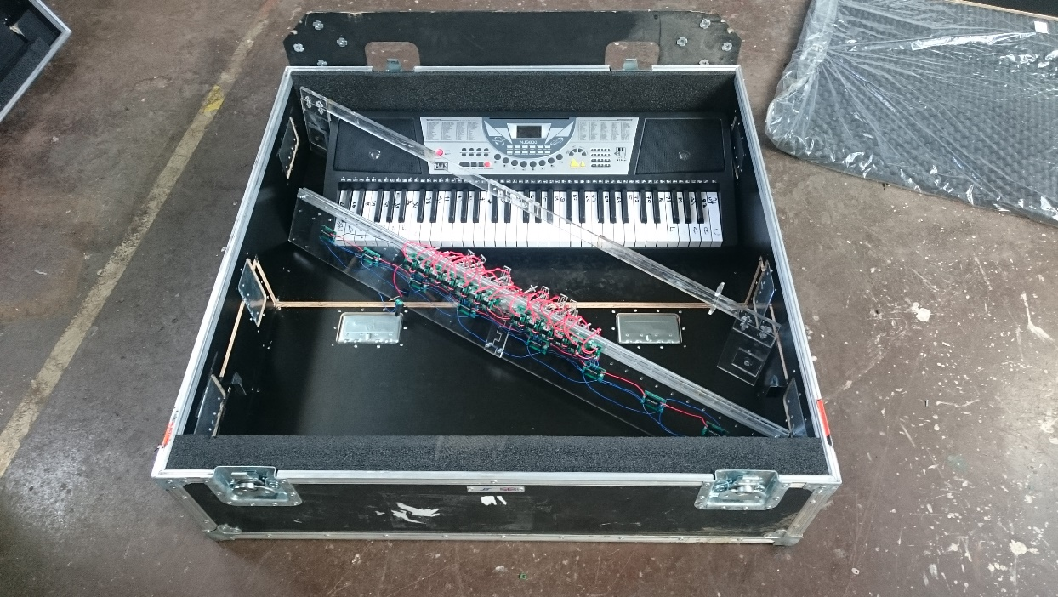

Figure 1. (a) Keyboard packed inside a flight case

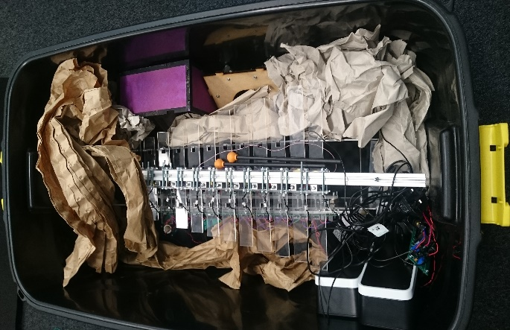

(b) Rest of the instruments packed

In total there will only be 2 containers used. This will be used in the future when the team will go to MOSI as mentioned in Section Outreach.